**Ideation Phase**

**Define the Problem Statements**

|  |  |
| --- | --- |
| Date | 19 September 2022 |
| Team ID | PNT2022TMID07105 |
| Project Name | Real time communication system specially abled . |
| Maximum Marks | 2 Marks |

**Customer Problem Statement Template:**

Create a problem statement to understand your customer's point of view. The Customer Problem Statement template helps you focus on what matters to create experiences people will love.

A well-articulated customer problem statement allows you and your team to find the ideal solution for the challenges your customers face. Throughout the process, you’ll also be able to empathize with your customers, which helps you better understand how they perceive your product or service.

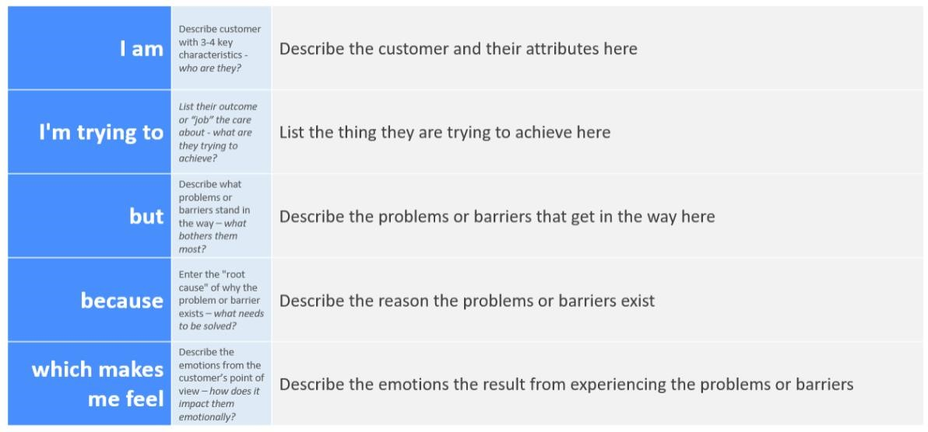

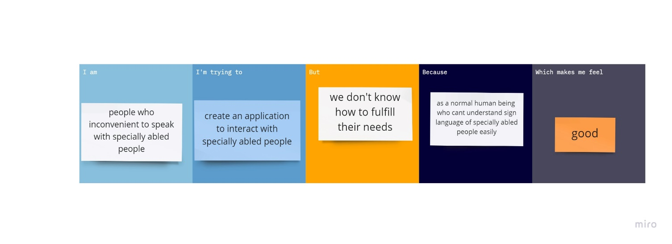

|  |  |  |  |  |  |  |  |
| --- | --- | --- | --- | --- | --- | --- | --- |
| **Problem**  **Statement (PS)** | | **I am**  **(Customer)** | **I’m trying to** | **But** | **Because** | | **Which makes me feel** |
| PS-1 | | People who inconvenient to speak with especially abled people | Create an application to interact with people | We don’t know how fulfil their needs | As normal human being who can’t understand sign language of especially abled | | good |
| Ps-2 | Better quality of picture to understand to Conway the message | | Save more time to search in internet or others | Propper needs of feedback | Can changes ours model or update | Customer choices | |